Lab 2: Containerization & Kubernetes Orchestration
Task 3: Docker Storage

1. Objective
Demonstrate two contrasting Docker storage behaviours using the Task 1 application's /data/counter.txt file: (a) data written to a container's writable layer is lost when the container is removed, and (b) data written through a named volume or a bind mount survives container removal.

2. Part A — Data Loss Without a Volume
The container was run with no -v flag at all, so /data/counter.txt exists only inside the container's own writable layer.
docker run -d -p 5002:5000 --name lab2-nostorage lab2-python-app:1.0
curl.exe -s http://localhost:5002/
curl.exe -s http://localhost:5002/
curl.exe -s http://localhost:5002/
docker exec lab2-nostorage cat /data/counter.txt

docker stop lab2-nostorage
docker rm lab2-nostorage

docker run -d -p 5002:5000 --name lab2-nostorage-2 lab2-python-app:1.0
curl.exe -s http://localhost:5002/
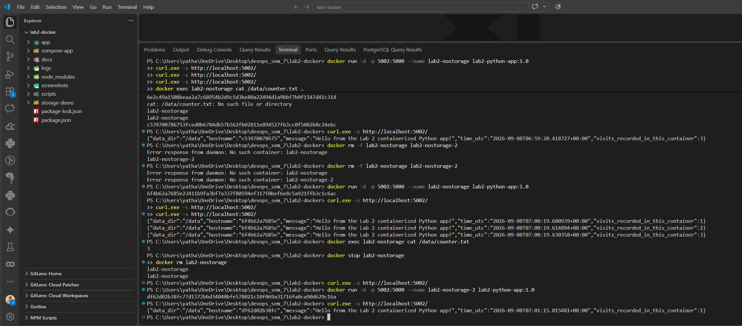

Step | Action | Counter Value
1 | Run container lab2-nostorage, call GET / three times | 1 -> 2 -> 3
2 | docker exec ... cat /data/counter.txt | 3 (confirmed on disk inside the container)
3 | docker stop && docker rm lab2-nostorage | Container's writable layer (and /data with it) is destroyed
4 | Run a NEW container from the SAME image, call GET / once | 1 <- reset, not 4

Because no volume or bind mount was attached, /data lived only in the removed container's writable layer. Once that container was deleted the layer — and the counter file inside it — was permanently gone, so the replacement container started from a completely clean /data directory.

3. Part B — Permanent Storage with a Named Volume
A Docker-managed named volume was created and mounted at /data so the data would live outside any single container's lifecycle.
docker volume create lab2-data-volume
docker volume inspect lab2-data-volume

docker run -d -p 5004:5000 --name lab2-vol-1 -v lab2-data-volume:/data lab2-python-app:1.0
curl.exe -s http://localhost:5004/
curl.exe -s http://localhost:5004/
curl.exe -s http://localhost:5004/

docker stop lab2-vol-1
docker rm lab2-vol-1
docker volume ls --filter name=lab2-data-volume

docker run -d -p 5004:5000 --name lab2-vol-2 -v lab2-data-volume:/data lab2-python-app:1.0
curl.exe -s http://localhost:5004/
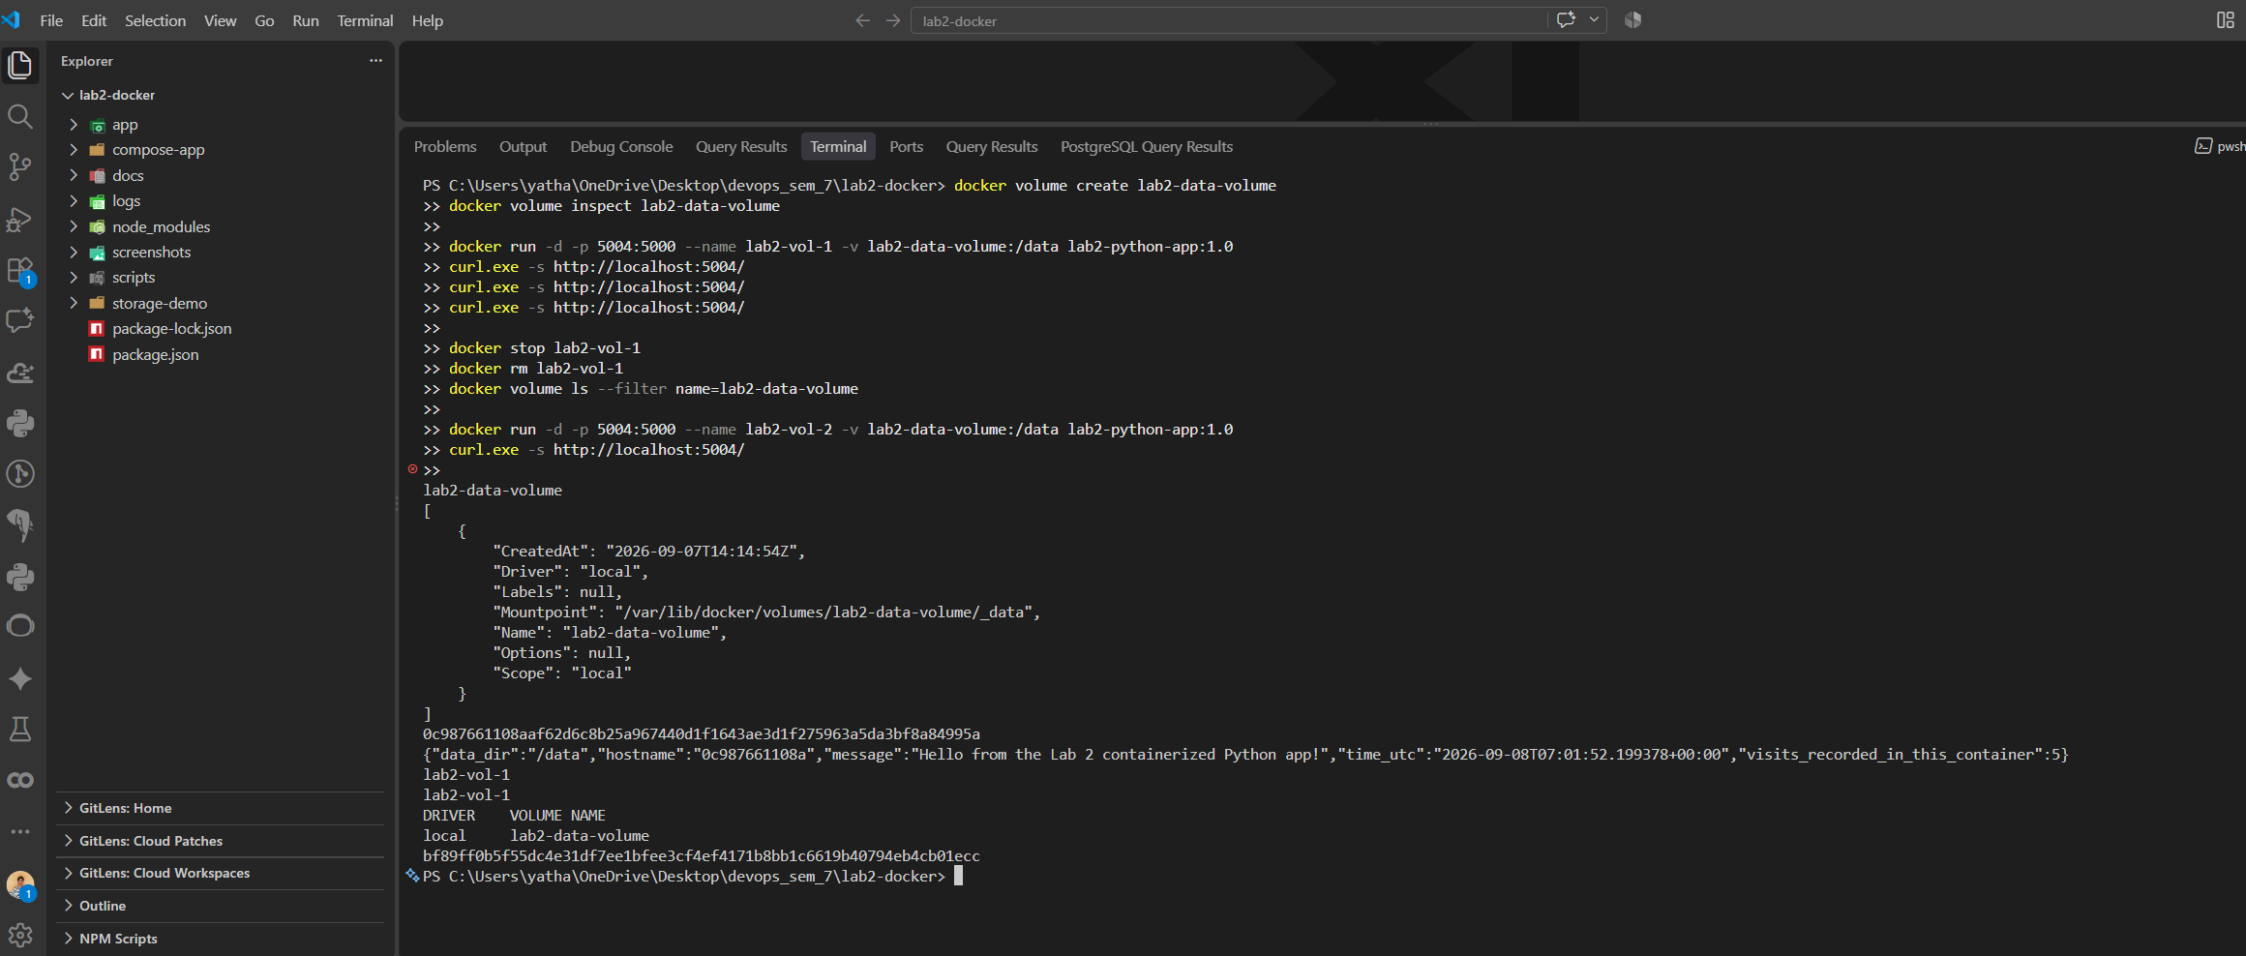

4. Part C — Permanent Storage with a Bind Mount
A bind mount maps a specific folder on the Windows host directly into the container, instead of a Docker-managed volume. In PowerShell, ${PWD} expands to your current directory; in Git Bash, use $(pwd) instead.
mkdir storage-demo\bind-data
docker run -d -p 5005:5000 --name lab2-bind-1 -v "${PWD}\storage-demo\bind-data:/data" lab2-python-app:1.0
curl.exe -s http://localhost:5005/
curl.exe -s http://localhost:5005/

type storage-demo\bind-data\counter.txt

docker stop lab2-bind-1
docker rm lab2-bind-1
dir storage-demo\bind-data\

docker run -d -p 5005:5000 --name lab2-bind-2 -v "${PWD}\storage-demo\bind-data:/data" lab2-python-app:1.0
curl.exe -s http://localhost:5005/
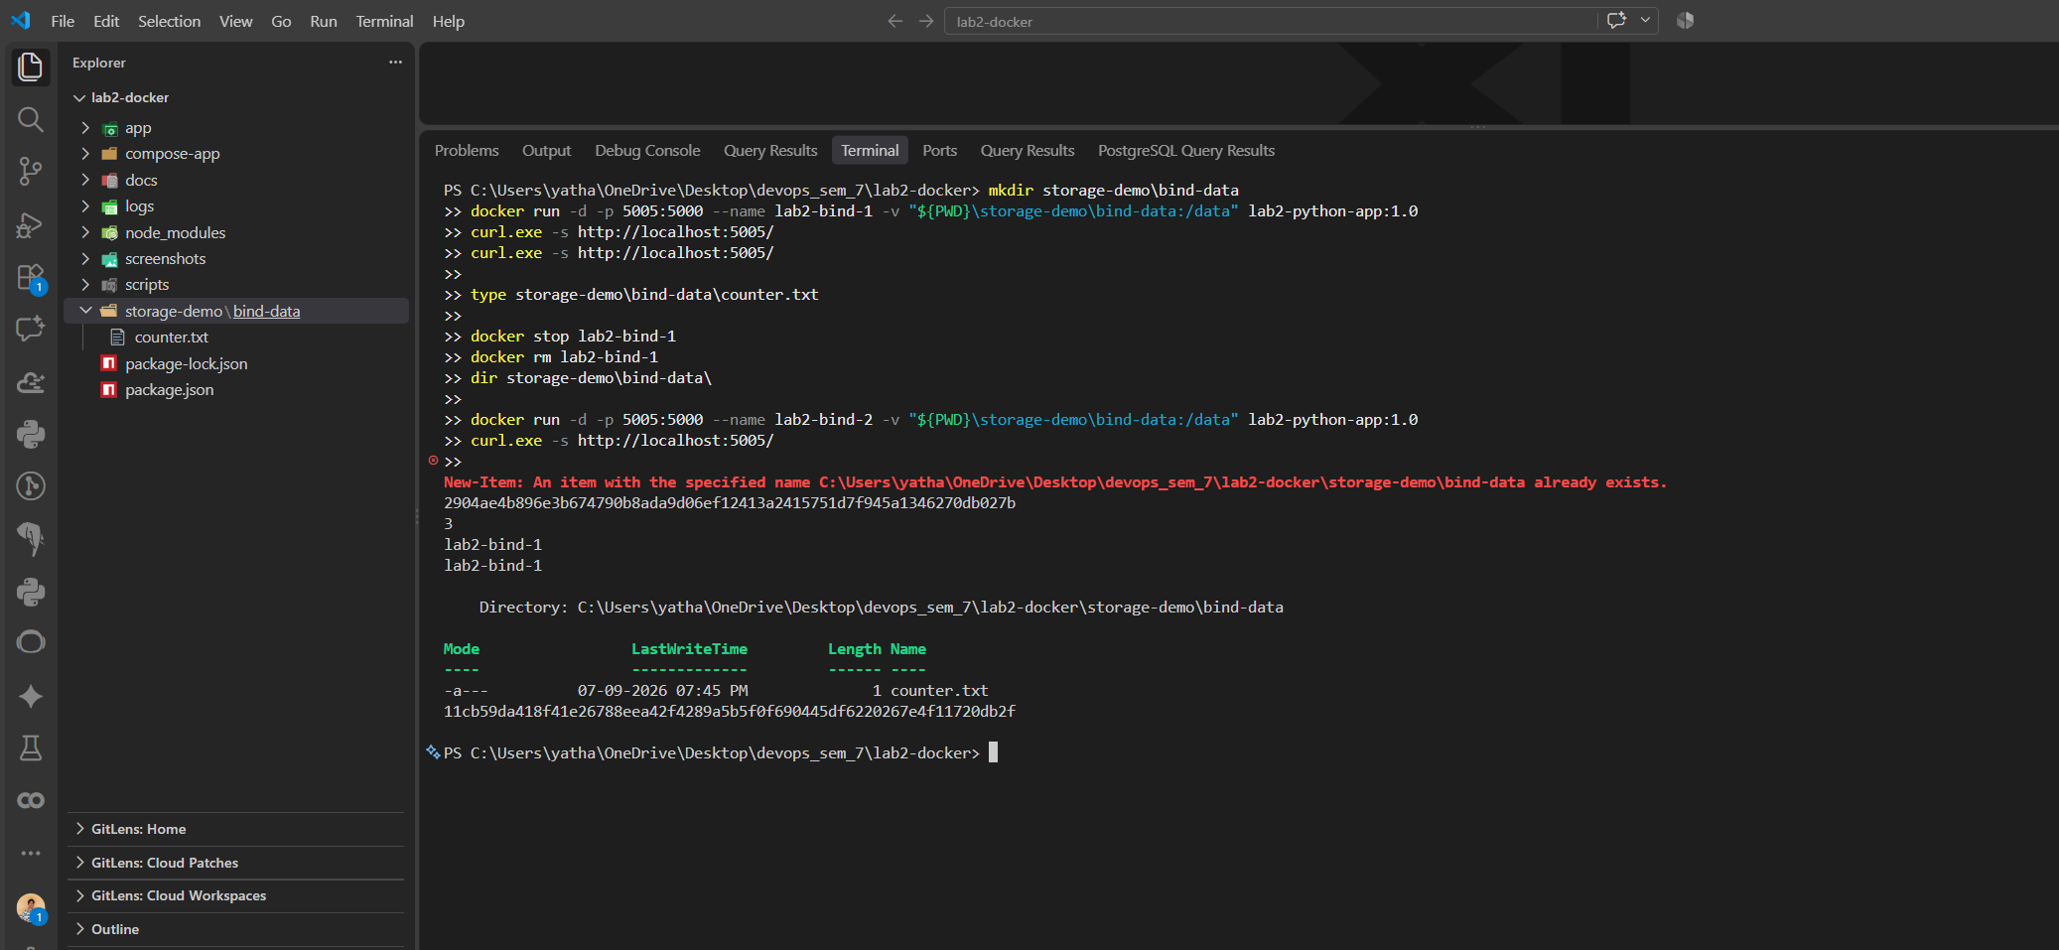

5. Comparison Summary
Storage Type | Where data lives | Survives docker rm? | Visible outside Docker?
No volume (container layer) | Inside the container's own writable layer | No — deleted with the container | No
Named volume | Docker-managed area (/var/lib/docker/volumes/...) | Yes — until docker volume rm | Only via docker exec / docker cp
Bind mount | A specific folder on the host filesystem | Yes — it's an ordinary host folder | Yes — directly, as normal host files

6. Conclusion
Three real container runs proved the storage model concretely: without a volume the counter reset to 1 after container removal (data loss); with a Docker named volume it continued from 3 to 4 across removal; and with a host bind mount it continued from 2 to 3, with the underlying file also readable directly from the Windows host, confirming both persistence mechanisms work as intended and behave differently from the ephemeral container layer.

